Name: Arpit Mahalle
Day 20 Output screenshots
Challenge 1:
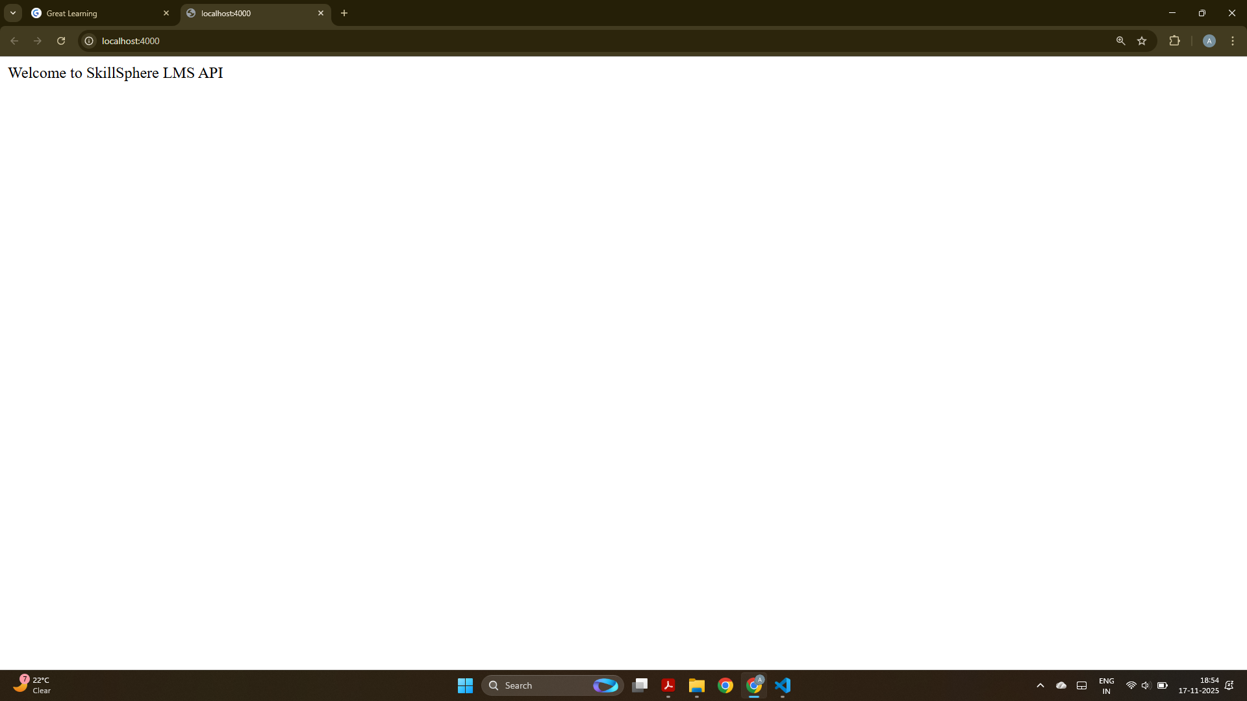
On visiting on http://localhost:4000/ it prints a welcome message i.e “Welcome to SkillSphere LMS API”
Challenge 2:
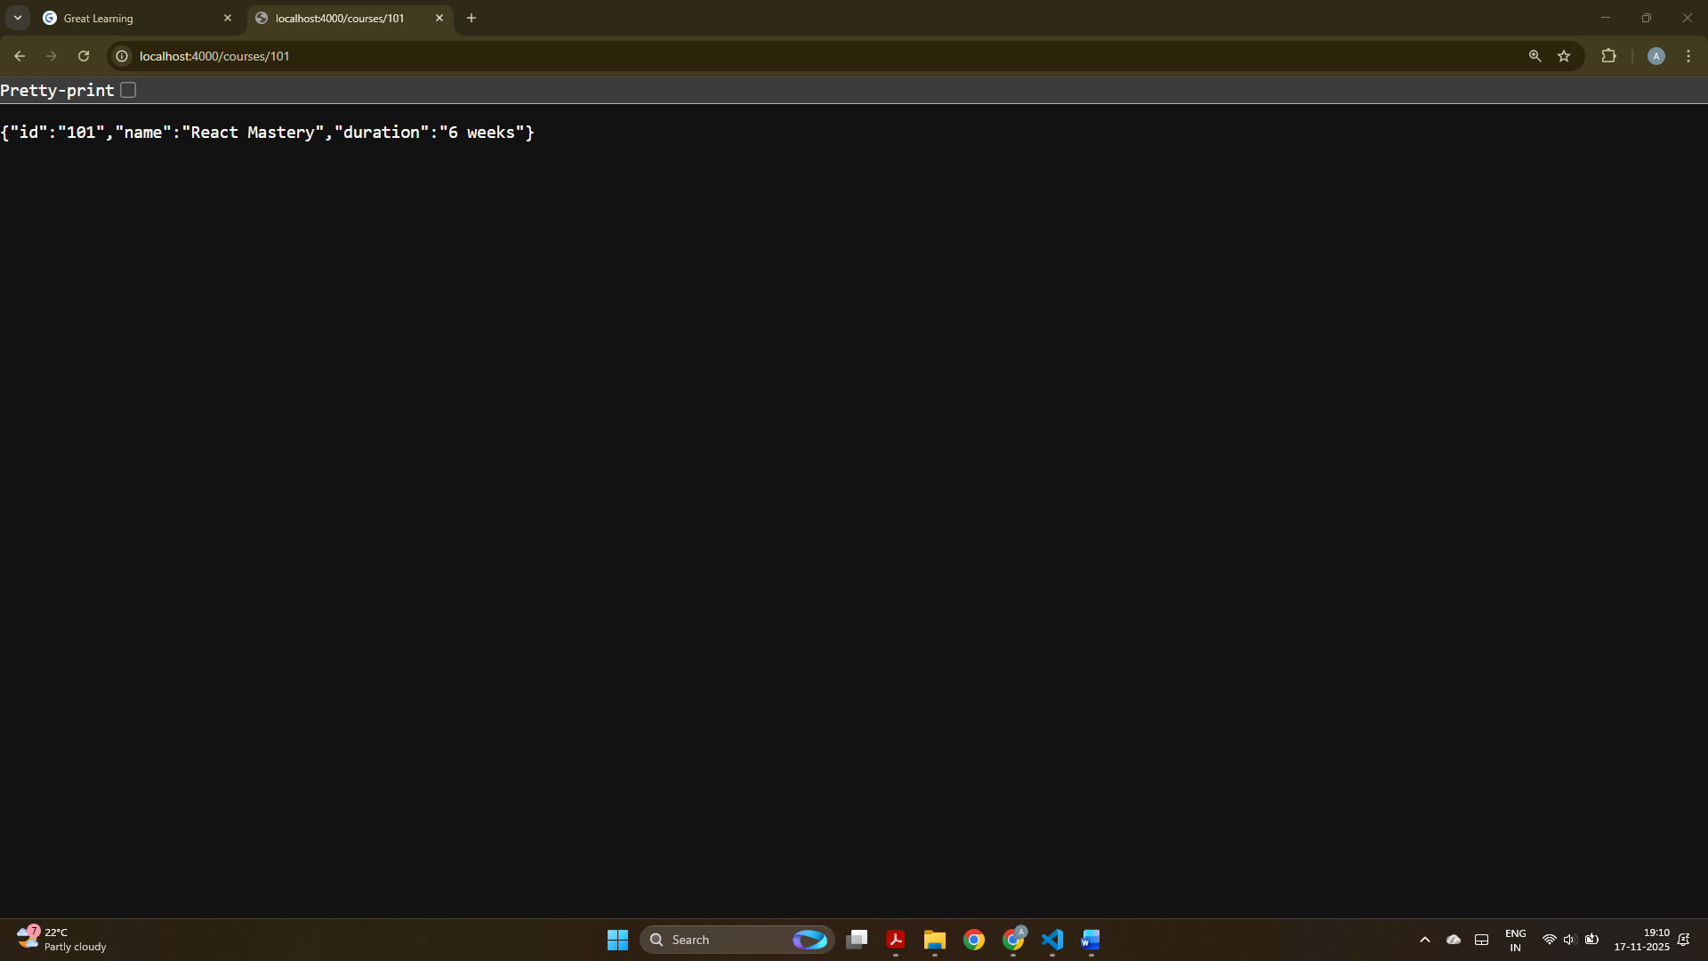
A valid numeric course id returns the correct course details, so this confirms that the route and middleware are working properly.
Challenge 3
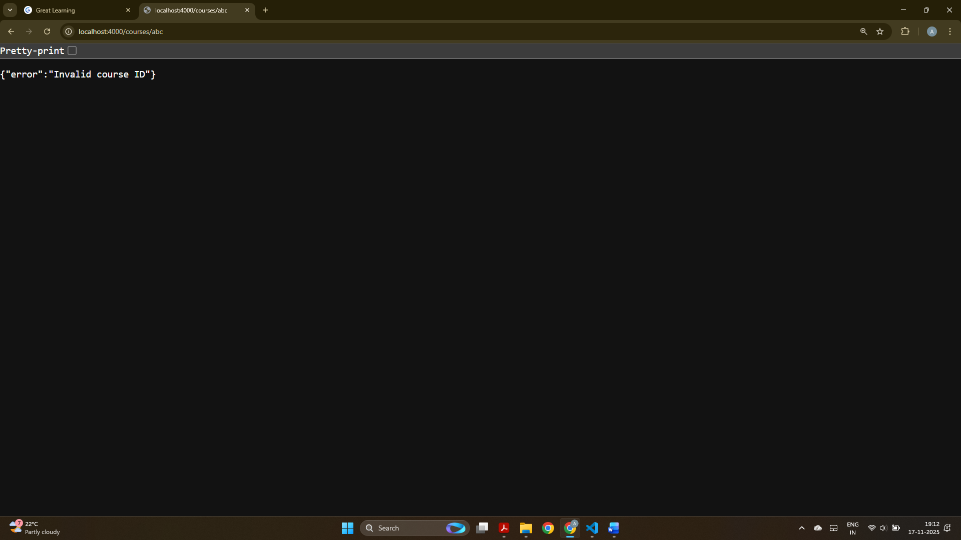
This screenshot displays an error message when we give an invalid course id, this proves that validation middleware is successful.

